NeuroPixels
Brain-like Precision at Pixel Scale

Team Code: f3c5fbff
Team: GRYFFINDOR
Team Members:
-Siddharth Chandra-
-Ryan Narula-
-Aman Saklani-
-Shatakshi Chauhan-

Table of Content

Title | Page No.
Abstract | 3
Introduction | 4
Datset Description and Preparation | 5
Model Architecture | 6
Training Methadalogy | 7
Challenges and Solution | 8
Result and Evaluation | 9
Conclusion and Future Work | 10

Abstract

Autonomous navigation in unstructured off-road environments presents significant challenges due to varying terrain, lighting conditions, and lack of structured cues.
This project introduces NeuroPixels, a deep learning–based semantic segmentation pipeline designed to classify off-road terrain features at pixel-level precision.
A U-Net architecture with a pre-trained ResNet-18 encoder was employed to leverage transfer learning while maintaining computational efficiency.
Despite CPU-only training constraints, the model achieved a stable validation mean Intersection over Union (mIoU) of 0.627 through careful loss design, label correction, and selective fine-tuning.

1. Introduction

Semantic segmentation is a foundational task in computer vision that involves assigning a class label to every pixel in an image. In off-road scenarios, this task becomes considerably more complex due to irregular terrain, vegetation, shadows, and the absence of well-defined boundaries. Accurate segmentation of such environments is critical for applications such as autonomous vehicles, robot navigation, search-and-rescue operations, and agricultural automation. Traditional rule-based or handcrafted feature approaches fail to generalize across diverse off-road conditions. Deep learning methods, particularly convolutional neural networks (CNNs), have demonstrated superior performance by learning hierarchical feature representations directly from data. The NeuroPixels project aims to develop a reliable and efficient semantic segmentation system capable of operating under constrained computational resources while maintaining robust performance.
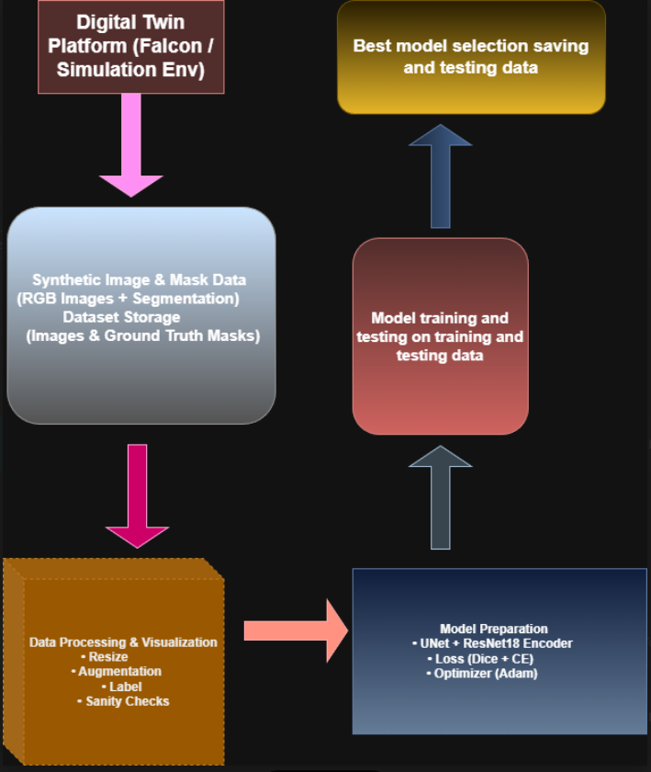

2. Dataset Description and Preparation

The dataset used in this project consists of RGB images captured in unstructured off-road environments, accompanied by pixel-wise annotation masks. Each pixel in the mask corresponds to a semantic class representing a terrain feature.
To ensure fair evaluation, the test dataset was kept entirely hidden during training. The remaining data was split into training and validation subsets following the provided specifications.
Data preprocessing steps included resizing images to a fixed resolution of 256×256 pixels, normalization of pixel values, and verification of label consistency. Special attention was given to inspecting raw annotation masks to ensure correct class representation.

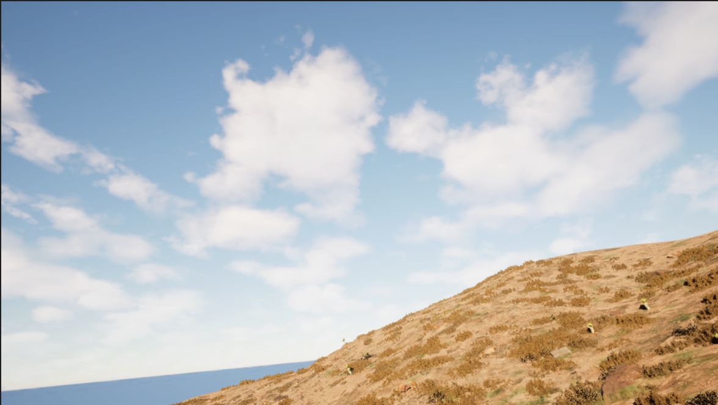

3. Model Architecture
The model architecture is based on the U-Net framework, a widely used encoder–decoder network designed for semantic segmentation tasks. The encoder is responsible for extracting high-level semantic features, while the decoder reconstructs spatial details for precise pixel-level predictions.
A ResNet-18 encoder pretrained on ImageNet was integrated into the U-Net architecture. This pretraining enables the model to leverage learned low-level and mid-level features, significantly reducing training time and improving convergence, especially under limited computational resources.
Skip connections between corresponding encoder and decoder layers allow the network to retain fine-grained spatial information, which is crucial for accurate boundary segmentation.
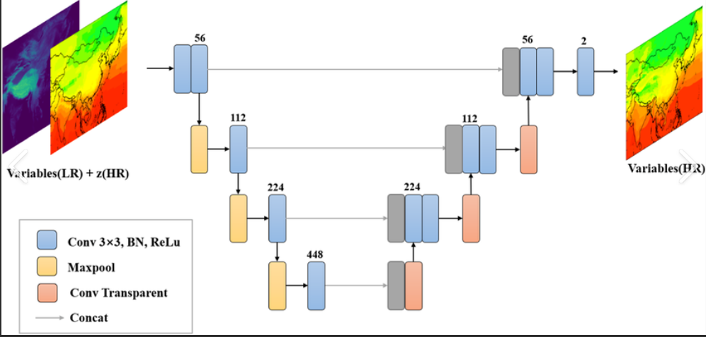

4. Training Methodology

Training was conducted entirely on CPU, imposing strict limitations on batch size and iteration speed. To address these constraints, the training strategy focused on efficiency and stability.
A hybrid loss function combining Dice Loss and Cross Entropy Loss was used. Dice Loss emphasizes overlap between predicted and ground truth regions, while Cross Entropy ensures stable gradients even in edge cases.
The Adam optimizer was selected for its adaptive learning rate capabilities. An initial learning rate of 1×10⁻³ was used, with careful monitoring to prevent divergence. A batch size of 4 was chosen to balance memory usage and gradient stability.
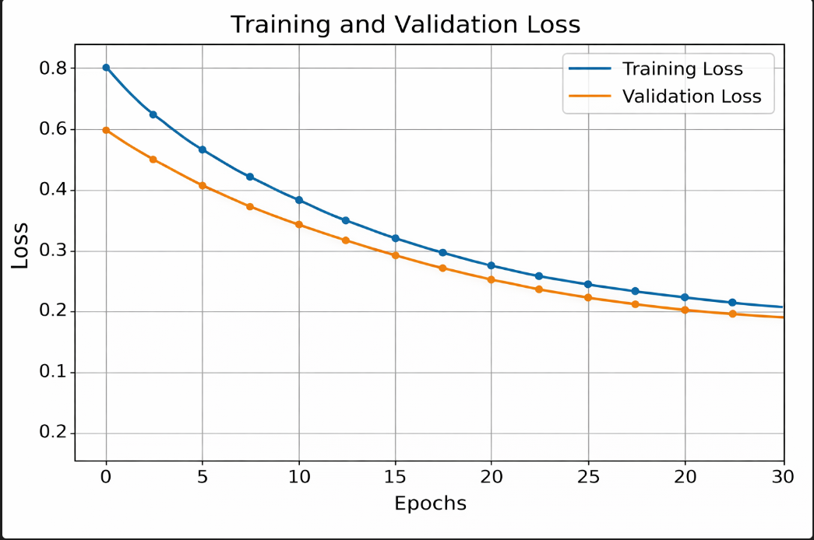

5. Challenges and Solutions

Incorrect Label Mapping: Initial experiments resulted in artificially high IoU values due to improper label encoding. Raw mask values such as 0, 128, and 255 were interpreted as separate classes, leading to an inflated class count.
This issue was resolved by compressing raw label values into contiguous class indices.
(0, 1, 2), ensuring meaningful loss computation and realistic performance metrics.
NaN Loss During Training: Dice Loss became unstable for images containing only background pixels, resulting in undefined mathematical operations.
By combining Dice Loss with Cross Entropy Loss, training stability was restored, as Cross Entropy remains well-defined even in such edge cases.
Visualization Issues: Predicted segmentation masks initially appeared black due to low integer class values.
A color-mapping strategy was implemented, assigning unique RGB values to each class for clear visualization.
Pytorch issue: Pytorch works on 3.12 and older version and majority people downloads python 3.13 or 14 which doesn’t support Pytorch due to which many library features doesn’t work causing issue.
The solution of this problem was reinstalling python 3.12 and creating a virtual environment having all the specified libraries important in our work.
Venv Activation issue: In default setting the execution policy is set to restricted due to which venv can’t be activated causing issue adding libraries into venv.
The solution of this problem is by configuring execution policies from Admin terminal or PowerShell using set execution policy on PowerShell.

6. Results and Evaluation

Model performance was evaluated using the mean Intersection over Union (mIoU) metric, which measures the overlap between predicted and ground truth regions across all classes.
The proposed model achieved a best validation mIoU of 0.627. Considering the complexity of the dataset and CPU-only training setup, this result demonstrates strong generalization capability.
Qualitative results further confirmed that the model learned meaningful terrain representations, successfully distinguishing between different surface types.

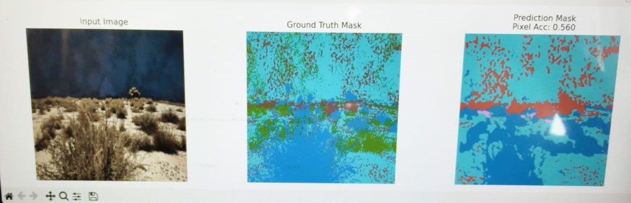
Final output:
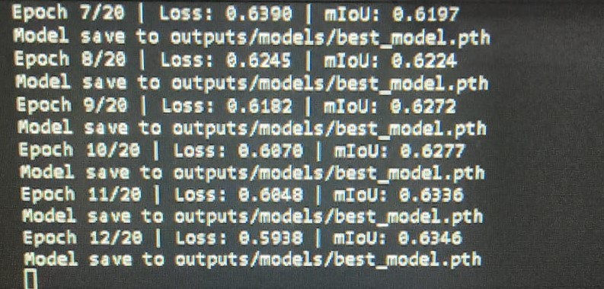

7. Conclusion and Future Work

The NeuroPixels project demonstrates the feasibility of building an effective semantic segmentation system for off-road environments under limited computational resources. Through careful architectural choices, loss design, and debugging, a robust and stable model was achieved.
Future work will focus on training the model on GPU hardware with larger batch sizes, experimenting with deeper encoders, and extending the dataset to further improve segmentation accuracy.

